## 2.1 Build a database

### Determine what kind of data needs to be presented in what manner

#### Cards

A card contains the following pieces of data:

* Title
* Due date
* Description
* Category
  + Name
  + Colour
* Status
  + Name
  + Colour
* Supervisor
  + Profile picture
  + Name
* Amount of points
* Is verified

All data is shown in the card layout as presented in the mockup.

#### Achievements

An achievement has the following pieces of data:

* Icon
* Name
* Description

The achievements are presented as row of tiles. The icon and name are directly visible as part of the tile. The description will be shown in a modal window.

#### Perks

A perk has the following pieces of data:

* Icon
* Name
* Description
* Cost
* Cooldown

The perks are presented as rows of tiles. The icon and name are directly visible as part of the tile. The description will be shown in a modal window.

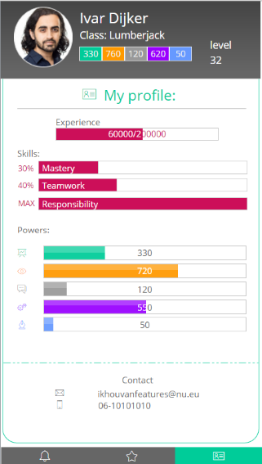On each row a bar is shown with the amount of spendable points for that skill.

#### Profile

The profile page has the following pieces of data:

* Amount of experience points
* Percentage of mastery skill completion
* Percentage of teamwork skill completion
* Percentage of responsibility skill completion
* Amount of ??? power points
* Amount of ??? power points
* Amount of ??? power points
* Amount of ??? power points
* Amount of ??? power points
* Contact information
  + Email
  + Mobile phone number

Each skill is represented as a progress bar. The contact information is shown as a simple list.

### Check the presented data if they are complete and can be used in a database

The presented data is thoroughly checked and deemed complete. The check was done by multiple people.

### Create solutions for the correct use of the data and determine the structure and specifications in procedures

Our solution for the correct use of the data is an extensive API which lies on top of the database. This API validates new data. It also guards against corruptions in the existing data.

### Inform our supervisor of the methods we use to consume the data

The supervisor was informed and agreed with the methods we use to consume the data.

### Test the data in the correct way and make changes if necessary.

The method of testing was to run the queries needed to create the different reports. Each of the queries returned successful, with all the necessary data.

### Is aimed to meet the expectations of the client

It was determined in several meetings that we as a group comply with the given requirements. As a result the tests are thoroughly run and the results are both checked and positive.